7-2 Final Project Submission

Aubierge Bikoi

CS 499

10/15/2022

**GitHub e-Porfolio Link:**

<https://github.com/aubierge1986/CS-499-Aubierge>

<https://github.com/aubierge1986/CS-499-Aubierge/tree/aubierge1>

**Code review Link:**

<https://www.youtube.com/watch?v=gehImZ6Zffw&authuser=0>

**Professional Self-Assessment:**

**Academic reflection:**

Hello, my name is Aubierge Bikoi, and I am in my senior year of Computer science right here at Southern New Hampshire university. This journey in Software Engineering started roughly four years ago. Completing this coursework helped me develop the skills required to succeed in this field such as problem solving, logical thinking, Software testing and debugging. I have also learned about computer programming and coding, as well as teamwork. As far as coding is concerned, I have had the chance to work with various coding languages such as Java, C++, Assembly, Python, C, Linux, SQL etc. Studying Software Engineering allowed me to work with hardware, software, math, physics; and I eventually developed some simple apps for my class projects. Throughout my computer science curriculum, I have learned about team collaborations and the Software Development Life Cycle. During that time, I was able to complete some assignments as a Scrum Master, Project Owner, as a Tester, and eventually as a Developer. This was part of group activities in class.  The Software development Lifecycle starts with a security mindset. Security should not be left till the end, to avoid getting data compromised by hackers. When it comes to programming, testing is very important, and it helps detect any malfunctions and bugs before they are too late to address. That is why a developer should test every section of the code and correct as he goes. While building apps, there were many times an app failed to test on the emulator, because there was an error on the code, or the API needed to upgrade to a newer version (example Android Studio). For this Capstone project, I had an issue with Android Studio project Structure. The app’s decency was outdated and need to be upgraded. However, after upgrading to a newer version, I got more issues with the app. I am confident the code is fine because it worked for the past few weeks. As a last resort, I started a new project using the same codes. Completing this Capstone course has also been a learning experience, and I always tried to determine the purpose of each section of my work, and the benefits to the users, before deciding how to complete my milestones. Although I took many courses throughout my curriculum, for this portfolio, my artifacts were selected in CS 260, and CS 360.

CS 260 dealt with Data structure and algorithm. Algorithms are fundamentally important in computer science, as they help understand computation. CS 260 provided me with an introduction to techniques for using data structures and algorithms, to solve basic problems. In CS 260, I learned about various types of algorithms and data structures such as search algorithms, sorting algorithm, Hash tables or even Graph Algorithms. Algorithms allow for better storage and efficient use of data. For instance, in the case of hashing, we learned that hashing was done by mapping a key element and values into hash tables. This helps getting faster access to data, and its efficiency depends on the efficiency of the function used.  For CS 340 introduced me to SQL and no SQL databases platforms, such as Mongo. CS 340 thought me how to create interactive dashboards and databases using MongoDB, Python, SQL, and JavaScript. Most of the coding assignments took place in Jupiter Notebooks using Python, as well as in the mongo shell using MongoDB and JavaScript. We learned how to upload excel files into mongo, how to create databases and collections, how to create tables in Mongo, how to add and delete data, as well how to create user authentication.  The CRUD methodology was implemented using Python and Mongo. For my final project, I have used Mongo DB in 3T, as well as SQL to perform this CRUD methodology, and to showcase my ability to work with a large database efficiently, using various coding languages and techniques. As for CS 360, this class taught me how to develop, test and launch a fully functional app. The course was hands-on, and thus we developed some very simple apps for our class projects.

**Portfolio Reflection:**

 For this Capstone Course, I wanted to select artifacts that would display all the skills I have acquired throughout this program.  My Code review’s artifact is a CPP’s code which was given to us as a class project in CS 410, as a binary folder. We converted the code into CPP and then into Assembly. However, the CPP’s code had some errors that I have addressed during the code review. Then the enhancement of this code consisted in correcting the errors and documenting the code.

For my enhancement one and two, I have selected an artifact from CS 360. It was a pizza party app, taken from the zyBooks, as a class activity. For my enhancement one, I have decided to comment the code in compliance with the best coding standards practices. I have also created a login page, and a menu for the pizza party app. Given that security is very important, every user of the app needs to be authenticated with login credentials. Therefore, to keep a security mindset, I have created a login page.  The intended purpose of the pizza party app, through its initial artifact, was to determine how much pizza would be needed for party goers, based on the number of guests, as well as their appetite. However, there was no pizza on the menu. That is why I have decided to add a menu page to the app.  These Enhancement to the first artifact allowed me to showcase my ability to employ strategies for building collaborative environment that enable diverse audiences to support organizational decisions.

The enhancement two dealt with algorithm and data structure. Initially, I wanted to enhance the algorithm of the app to help users select the amount of pizza based on other factors such as buying habits, their names etc. However, I did not want to reuse the existing code, to avoid redundancies. Nevertheless, as a developer, we need to use users’ feedback, to improve the quality of our services to customers. That is why, in this section, I have decided to create a rating page for pizza parties. While testing the rating section, I left a couple of reviews for the pizza party.  Choosing this enhancement has allowed me to showcase my ability to design and evaluate computing solutions that solve a given problem using algorithmic principles and computer science practices.

The artifact selected in the enhancement three, was an excel spreadsheet used in CS 260, to create an algorithm using C++. This spreadsheet is an excerpt from Nashville’s e-Bids website, which provides the list of surplus auctions in the state of Tennessee. My enhancement to this project was to create a CRUD methodology for this large database, using MongoDB. I have also been able to make the data more manageable, using Mongo and SQL queries. Also, because we cannot leave security for the end, I have started implementing these safe practices from the moment I set up my account and created a cluster. Then I created user authentication, which was later linked to my 3T app, to use Mongo on 3T. Using what I learned in CS 340, I was able to use various databases and coding languages to create an interactive dashboard for a given file. In this section, I was able to demonstrate my ability to use well-founded and innovative techniques , skills and tools in computing practicing, for the purpose of implementing computer solutions that deliver value and accomplish industry specific goals.

Given that I have used three different artifacts for this portfolio, these projects do not correlate with each other.  However, each of these artifacts have been used to showcase my abilities to implement software Engineering's best practices and technicalities.

**Enhancement one:  Software Engineering and Design**

A- describe the Artifact

What is it? When was it created?

This artifact, from CS 360, was a class project. It was a Pizza party app, used to determine how much pizza was needed based on Two factors: the number of guests and their appetite.

Initial artifact:

Enhancement:

1. Login page:

1. Pizza Meu:

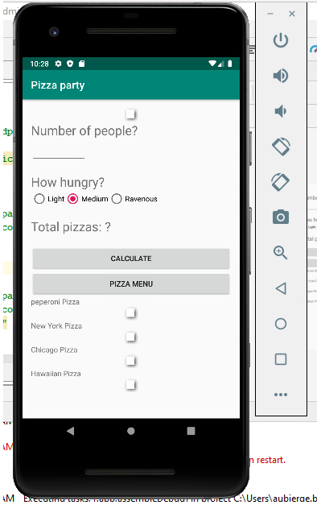

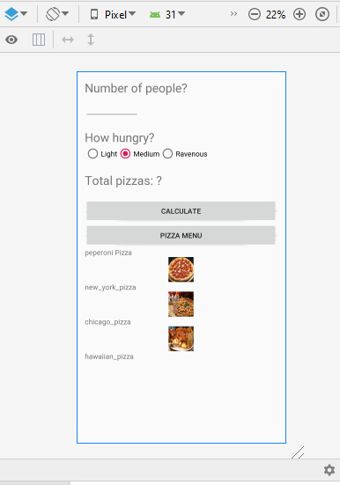 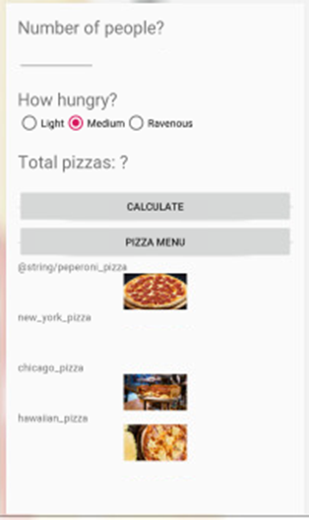

B- Justify the inclusion of the artifact(s) in your e-Portfolio

**Why did you select this item? What specific components of the artifact showcase your skills and abilities in software development?**

I have selected this artifact because this application was very basic and did not really have specific search features for the users. To keep the users engaged and interested, I decided to include a menu, so that to the pizza party goers could stay engaged. Using data mining techniques, I selected the fourth most popular pizza consumed domestically, and I included them in the menu. Also, to provide a first line of defense against unauthorized access to their accounts, I have created a login page for the users. They could login with their username and password, and they could also login using social media such as Google, and Facebook. These two enhancements allowed me to showcase the ability to use innovative skills and techniques for implementing design solutions and accomplishing goals, but also to demonstrate the ability to address potential design flaws related to security.

C- Reflect on the process of enhancing and/or modifying the artifact.

**What did you learn as you were creating it and improving it? What challenges did you face? How did you incorporate feedback as you made changes to the artifact? How was the artifact improved?**

The biggest challenge I faced with this enhancement was really deciding what to enhance. Initially, I intended to add a menu, and a basic camera feature to the app. However, most users come to an app to achieve a specific goal. Therefore, to address the security concerns pertaining to the design as well as to address these goals, I have opted for a login page, as well as a menu. Another obstacle I encountered was having to constantly update Android studio to a newer version. Some days it worked just fine, and other days it did not work at all.

**Enhancement Two: Data Structures and Algorithm**

A. Briefly describe the artifact.

**What is it? When was it created?**

The artifact I used in this section is the same I used for the software engineering and design section of my project. It is a pizza party app used in a CS 360 class project in 2020. This app was used to calculate the amount of pizza needed for a party based on the number of guests and their appetite.

Initial artifact:

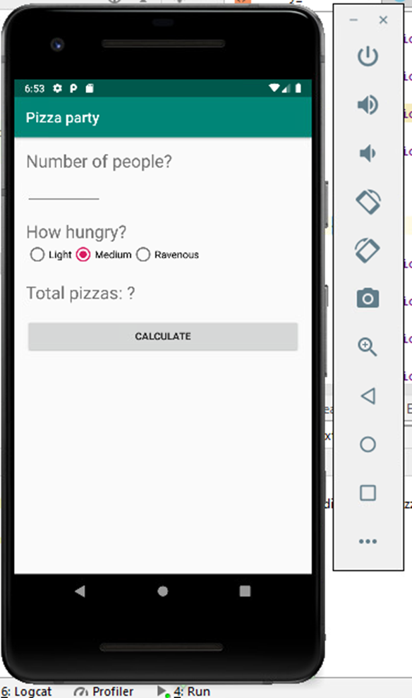

Enhancement:

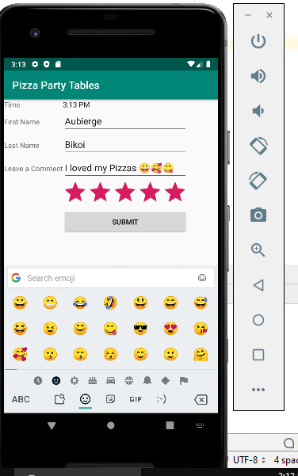

 B. Justify the inclusion of the artifact(s) in your e-Portfolio.

**Why did you select this item? What specific components of the artifact showcase your skills and abilities in software development?**

I have included this artifact in my project because developers are always improving their products. Getting feedbacks from users is a very good way of knowing why the application is being used or not, and why some applications have more subscribers than others. Algorithms are used to give a command to computers, based on a specific goal. In this case, the algorithm was to find out the number of pizzas. However, algorithms work with databases, and in this case, there was no database to work with. That is why for this section, I have decided to create a rating page. After creating the rating page, I rated the app twice in the emulator, just to see what features were available for the user's review. I left some stars, some comments, and I included some emojis. This allowed me to demonstrate the ability to program solutions to solve logic problems involving algorithms or data structures

C. Reflect on the process of enhancing and/or modifying the artifact.

**What did you learn as you were creating it and improving it? What challenges did you face? How did you incorporate feedback as you made changes to the artifact? How was the artifact improved?**

For this section, I learned that having the upgraded version of the API saves a lot of time. I spent a lot of time trying to update to a newer version, but I still had a hard time running the whole app using the previous setting. As a result, I created a new project, and I submitted each enhancement separately. I have used the table layout and I used two columns' tables. The first column has the structure type that I used, and the second column contains the names of these structures. Algorithms help store data efficiently. That is why using the right data structure can help with data storage. By a rating our app, users can either rate with stars, or leave a comment about their experience. They can let us know how we can better serve them.

**Enhancement Three: Databases**

A. Briefly describe the artifact.

**What is it? When was it created?**

This artifact is an excerpt from the Nashville Tennessee E-Bid’s website. It is an excel spreadsheet that includes the list of all the Government’s surplus Bids, and we used it in CS 260, to develop a C++ algorithm.

Initial Artifact:

Enhancement:

**Importing a file into MongoDB:**

To import the e-Bid file into Mongo, I right clicked on collection, and I selected import a collection. I selected the CSV format and I clicked on “configure”.

To view the document using Mongo query, the following code has been entered in the Mongo Shell:

// Requires official MongoShell 3.6+

db = db.getSiblingDB**(**"e-Bids"**);**

db.getCollection**(**"eBid_Monthly_Sales"**)**.find**({});**

**Output using tree view**

Tree view allows us to view data classified in 3 categories, mainly: Key, value, and data type. If I click on the first key, I can get all the following information pertaining to the first key item.

On the view table icon, the documents are displayed in many columns. To filter by Id, I clicked on the ID column and searched for the requested ID as shown below:

The JSON format allows us to view how the documents are collected and stored in the MongoDB database.

To build a Query using Studio Query drag and drop query interface, I used the following steps:

> click on visual query builder, to open the query form

> then click on the “+” icon to add a search condition

> once the search expands, the first drop down menu will include the collections’ fields.

> from the list, I selected the Auction Title’s field

>The second drop down menu contains the list of operators defining the search. From the list, I selected “contains”

>in the string icon, I typed Dell Laptop, then I ran the query. The result showed me only a list of Dell Laptops’ auctions.

I was able to locate 1376 documents pertaining to Dell Laptops’ auction.

If I wanted to narrow down my search to exclude any auction from Dell laptops in the ITS department, I could drag ITS and add it in a new string. In the drop-down menu, I selected “doesn’t equal “and I found 294 auctions not performed by the ITS department.

The following code could also be entered in Mongo DB shell, to get the same result:

// Requires official MongoShell 3.6+

db = db.getSiblingDB**(**"e-Bids"**);**

db.getCollection**(**"eBid_Monthly_Sales"**)**.find**(**

**{**

"Auction Title " **:** /.*Dell Laptop.*/i**,**

"Department " **:** **{**

"$ne" **:** "ITS"

**}**

**}**

**);**

If for instance, I do not need any information from the Business Unit and the Net Sales, I can go to projection, and exclude these two sections as shown below.

Mongo DB code:

// Requires official MongoShell 3.6+

db = db.getSiblingDB**(**"e-Bids"**);**

db.getCollection**(**"eBid_Monthly_Sales"**)**.find**(**

**{**

"Auction Title " **:** /.*Dell Laptop.*/i**,**

"Department " **:** **{**

"$ne" **:** "ITS"

**}**

**},**

**{**

"Business Unit" **:** 0.0**,**

"Net Sales" **:** 0.0

**}**

**);**

In the case of a large dataset, MongoDB allowed me to reduce the data to a more manageable set of data while testing the queries. If I wanted to go back to the default view, I could right click anywhere in the data set and select restore default view.

**To update data:**

In the result tab, I double clicked the “Fire” value under “Department” field, to enter the editing mode. In this case, I changed the value to “White House”

**Before:**

**After:**

In this case only one entry was updated by following these simple steps:

* Right click one of the values in the field I want to edit
* select field
* select edit value/type
* select it 64
* select document matching query criteria
* click only change type
* enter 0 in fall back value and then click set value

A message box indicated that all values have been updated.

To update a bulk of data in the department field at the same time, I can repeat the same process by clicking on Always force values:

* Right click one of the values in the field I want to edit
* select field
* select edit value/type
* select it 64
* select document matching query criteria
* click only change type
* click on always force values, and change the value of Health to Massachusetts

We can now see that all values in the department field have been updated to MASSACHUSETTS.

Previously I have imported data, created a database and a collection. I have also removed unwanted data and I have updated data using MongoDB. This allowed me to implement the CRUD Methodology (Create, Read, Update, Delete).

In the Next section I will be running a SQL Query in MongoDB

Using the SQL Query tool, I have been able to launch SQL, and I should also be able to retrieve information from the e-Bids_Monthly_sales file.

**Result:**

**Exporting Data in JSON file:**

**Result:**

Using 3T Studio has allowed me to connect my MongoDB account directly with my Atlas account to authenticate myself using the IP address, and the credentials I created while setting up my cluster in Mongo.

In the Mongo shell, the following code can also be added to create user authentication.

For instance, If the user is Username and the password is Password, we can enter the following code in the MongoShell , under collection:

> use admin

> db.createUser(

{

user: "Username",

pwd: "Password",

roles: [ { role: "userAdminAnyDatabase", db: "admin" } ]

}

)

In this Milestone, I have been able to work with large amount of data using both SQL and MongoDB. Although Mongo Cluster was somehow different from the classroom’s version, I was able to use the platform to complete this assignment. I have been able to implement the CRUD methodology using MongoDB, which was one of my planned enhancements for this artifact. I have also been able to use SQL queries while using Mongo, to search for specific data, or to make data more manageable, by removing the unnecessary items. As always, it is important to develop a security mindset, from the time we configure our account to the moment we manage data. That is exactly what I was able to achieve by creating a user authentication for my cluster. This allowed me to showcase my ability to program solutions, and solve problems involving storing, manipulating and access data.

B. Justify the inclusion of the artifact(s) in your e-Portfolio.

**Why did you select this item? What specific components of the artifact showcase your skills and abilities in software development?**

I have selected this artifact for the database portion of my project because I wanted to showcase my ability to access, manipulate, and store data using MongoDB (NoSQL) as well as SQL.

This artifact was initially an excel spreadsheet. Using Mongo and 3T platforms, I was able to create a cluster with user authentication, to then set up a database and a collection for this data. As part of my enhancement plan, I wanted to implement the CRUD (Create, Read, Update, Delete) methodology for this data, and I did.  These documents were reviewed using both tree view and JSON view. When I uploaded this file on MongoDB, I imported a total of 39476 files into MongoDB. That is a large amount of data. To search for specific data, I was able to build queries using Mongo and SQL. I was able to narrow down my searches in some cases by excluding some of the unwanted items, or by entering a mongo code, which excludes the items automatically.  This demonstrated my ability to program solutions to solve problems involving storing, manipulating, or accessing data.

C. Reflect on the process of enhancing and/or modifying the artifact.

**What did you learn as you were creating it and improving it? What challenges did you face? How did you incorporate feedback as you made changes to the artifact? How was the artifact improved?**

Throughout this program, I have always been told not to leave security for the end. Unlike the class version of MongoDB, which was already set up for us to use, I had to create an account with Mongo and set up a cluster. Since my cluster was not working, I sent an inquiry to the MongoDB 's team, to understand why I could not upload a file online. Mongo's engineers did not know what I was asking. Furthermore, after going back to CS 340 course announcements' notes, I used the link provided by the instructor. The search icon led me to the 3T app. Using 3T required me to set up my user's authentication in Mongo and copy the link to 3T Studio to launch Mongo with my account using 3T. In the password section, I entered the password I created while setting up my cluster and then I was able to work. Using 3T is like using the Apporto platform we used in class, with some nuances. Instead of python, I had free access to SQL which was great. I was able to upload the files into my collection, and implement the CRUD methodology, as part of my enhancement plan. I was able to search for a specific item in a database of over 30 thousand files, using a simple query. The items could either be located by their Id number, or by category. In this section, I had a chance to update one data or a block of data. 3T also allowed me to return data to their original versions if needed.